Create two IAM users named developer-user and tester-user.
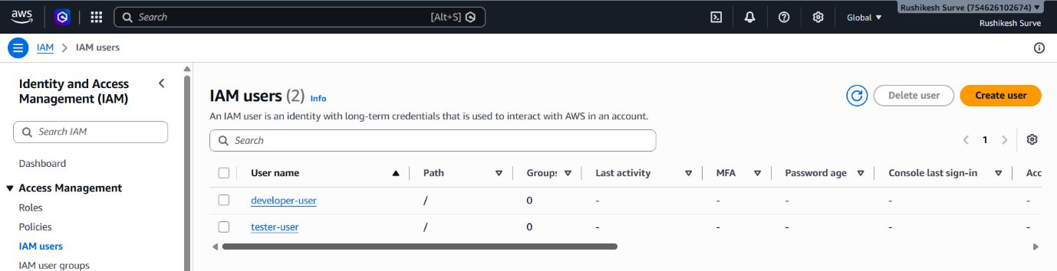

Create two IAM groups named Developers and Testers.
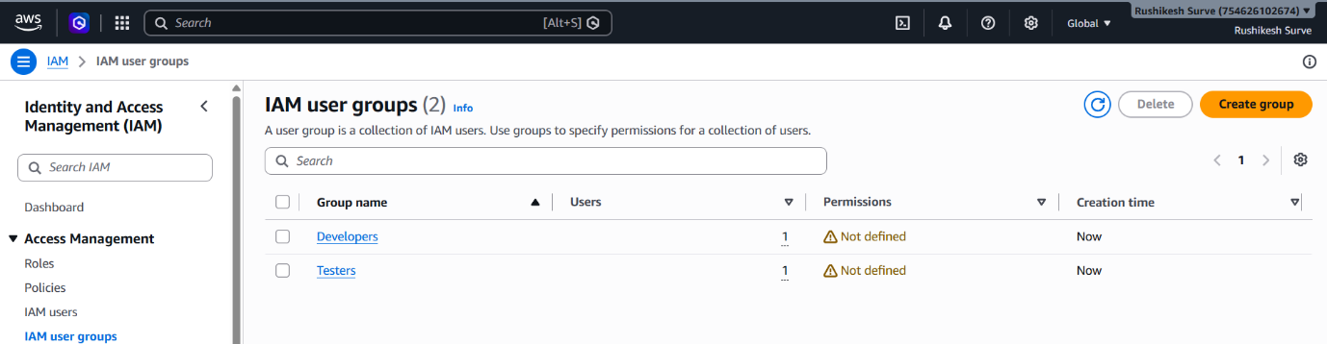

Add developer-user to Developers and tester-user to Testers.

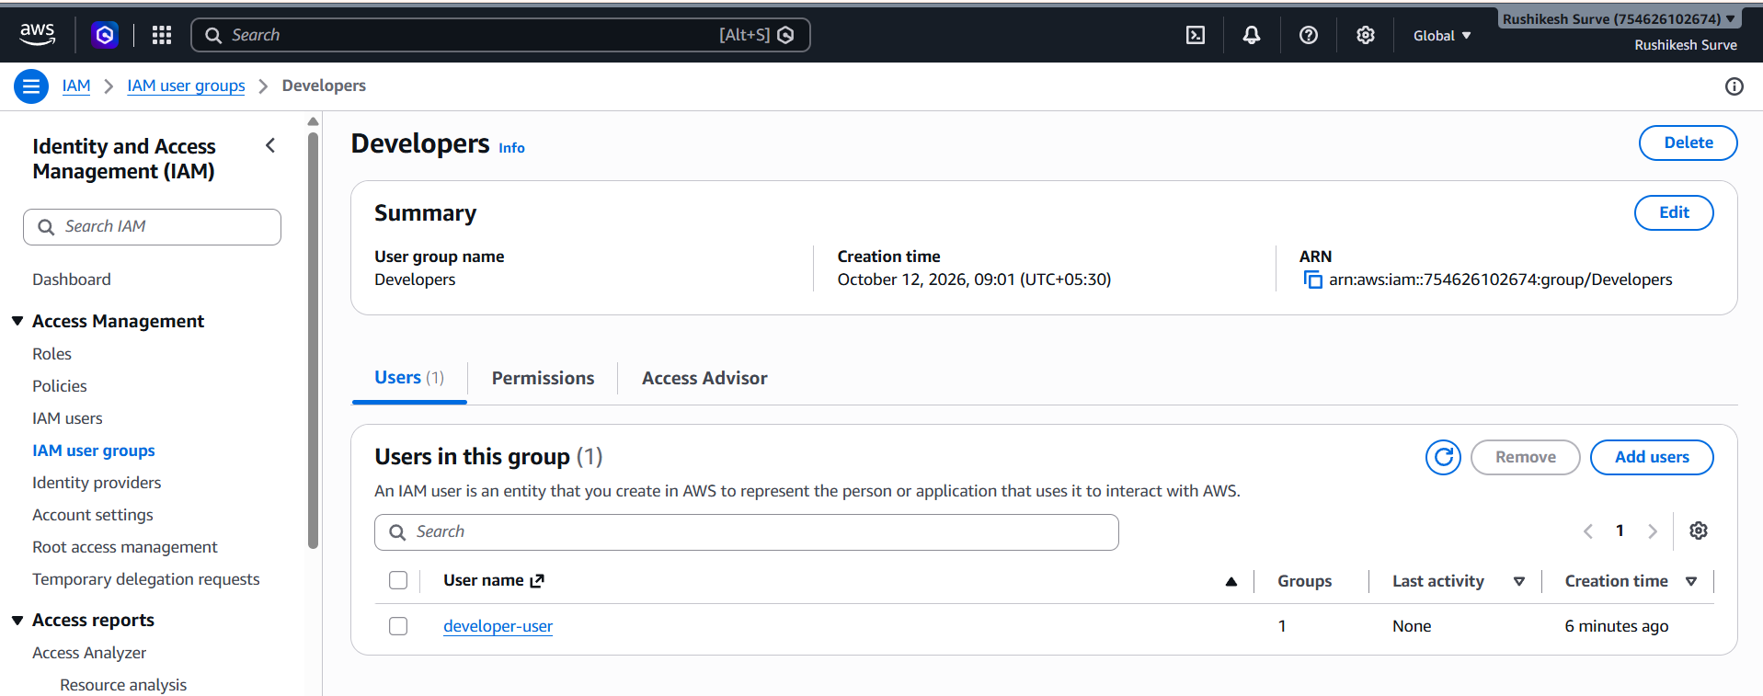

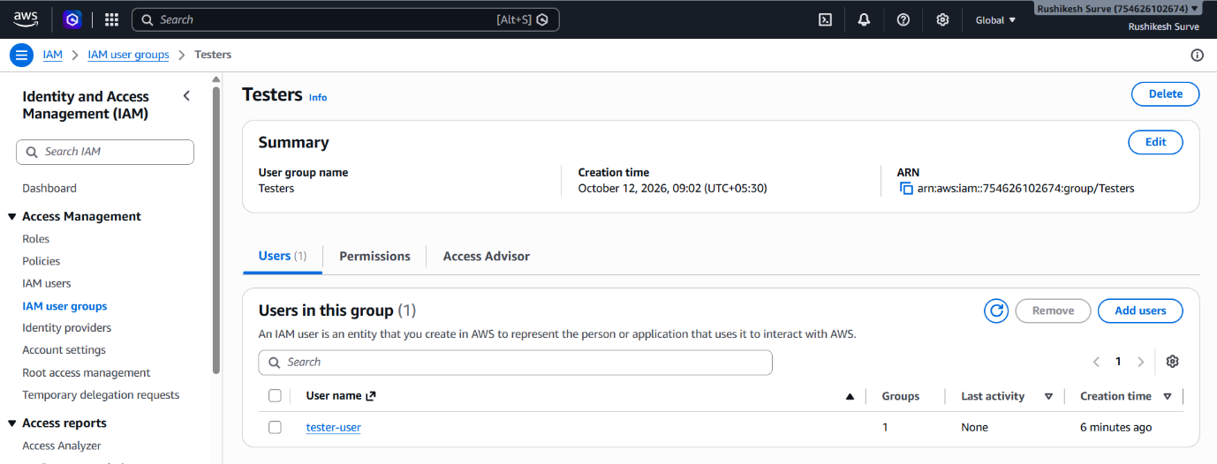

Attach the AWS managed policy AmazonS3ReadOnlyAccess to the Developers group.

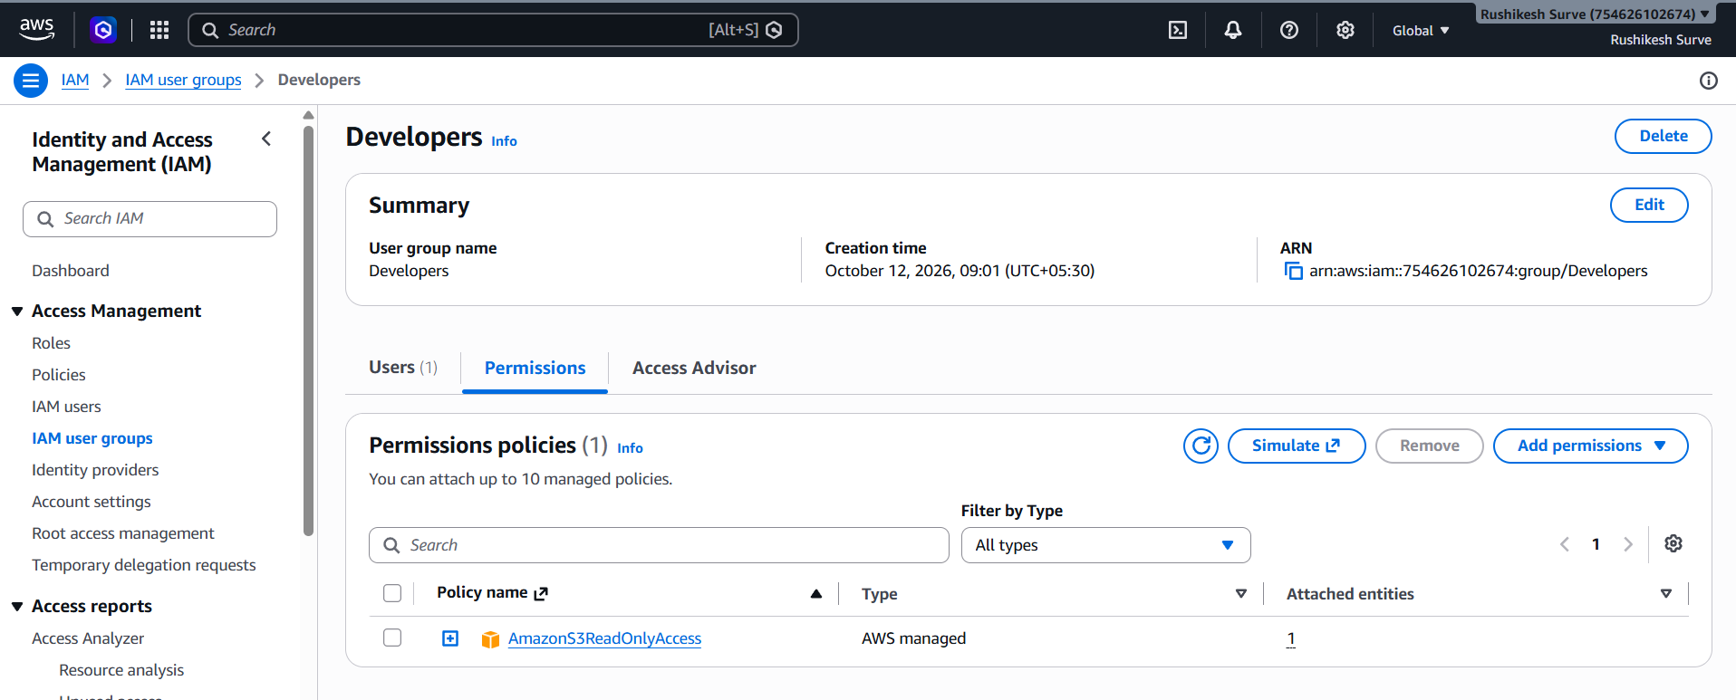

Attach the AWS managed policy AmazonS3FullAccess to the Testers group.

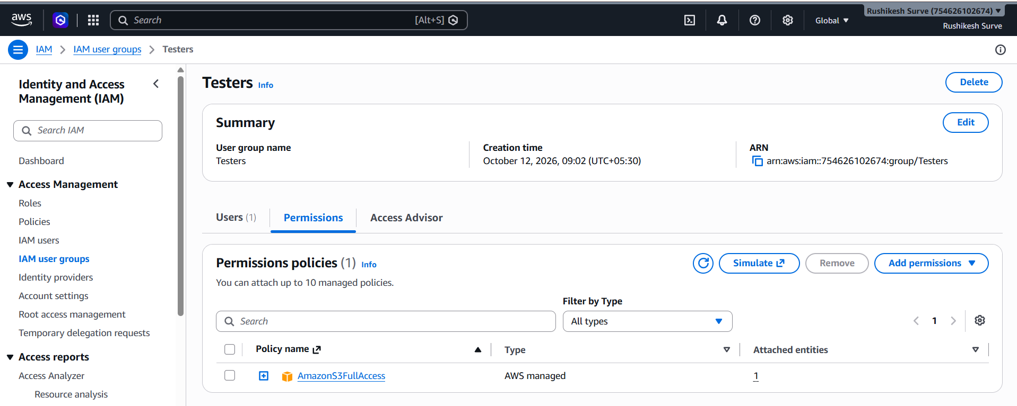

Create a customer-managed policy named CustomS3ReadPolicy.

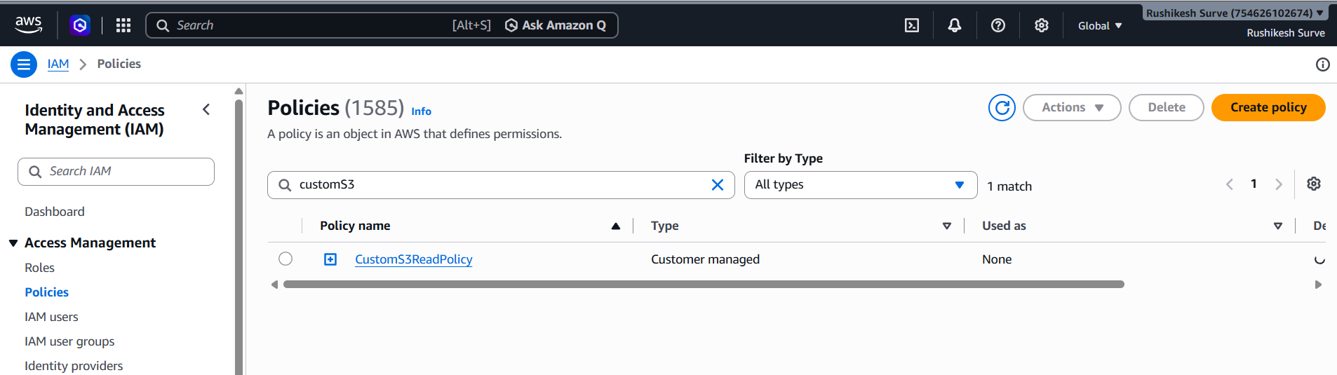
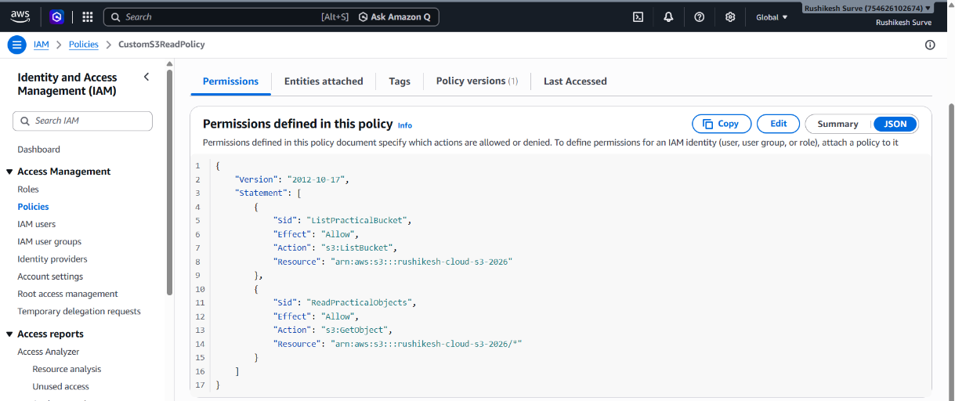

Attach the policy to the appropriate test user or group. Use your actual bucket ARN and object ARN in the policy.
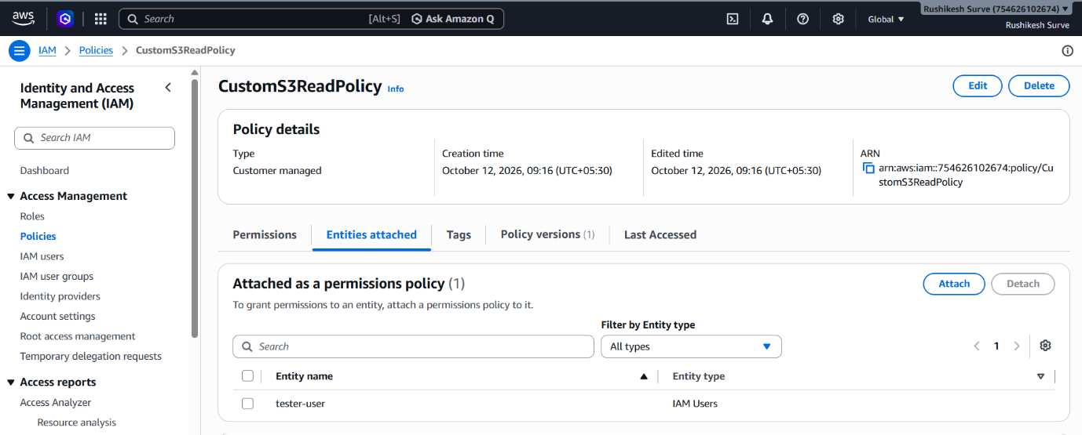

Create an IAM role named EC2S3ReadRole with EC2 as its trusted service.

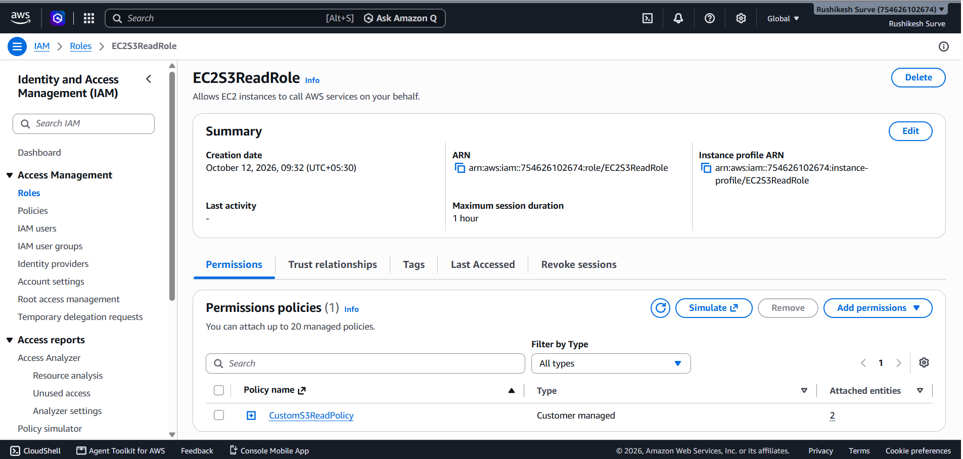

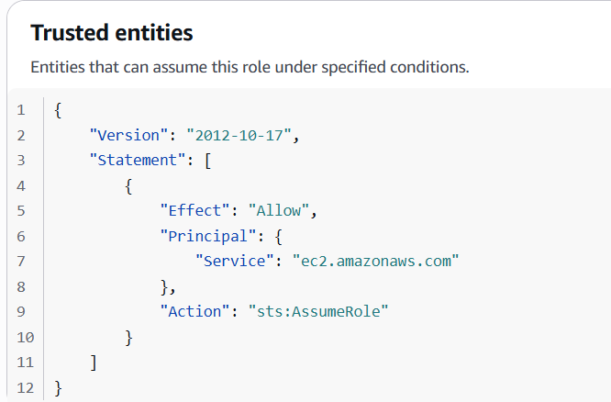

Sign in as developer-user or use an instructor-approved test method.

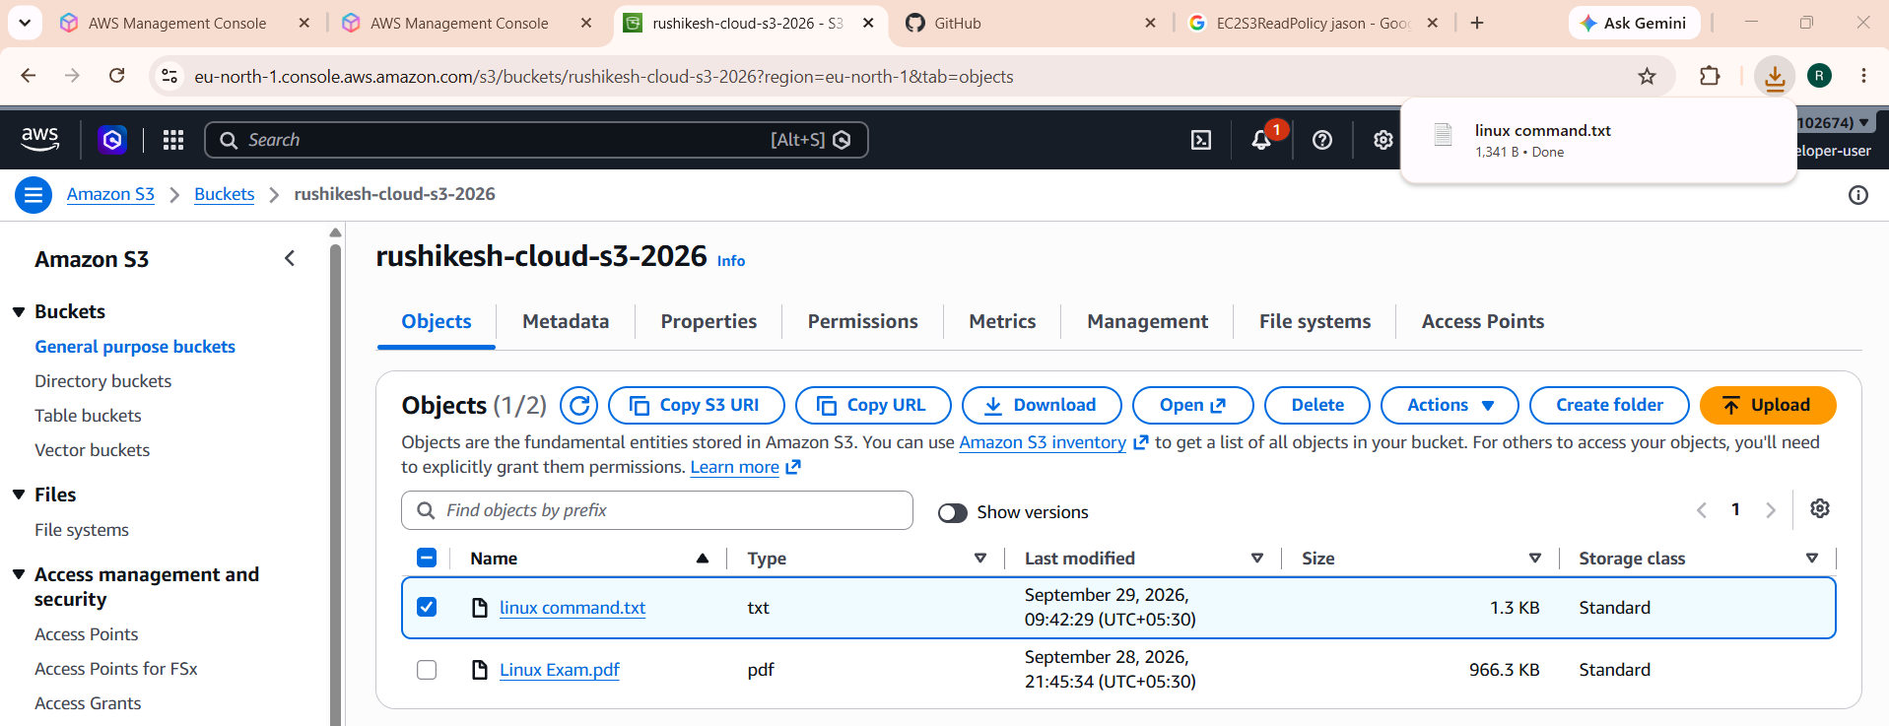

Verify that uploading and deleting objects are denied.

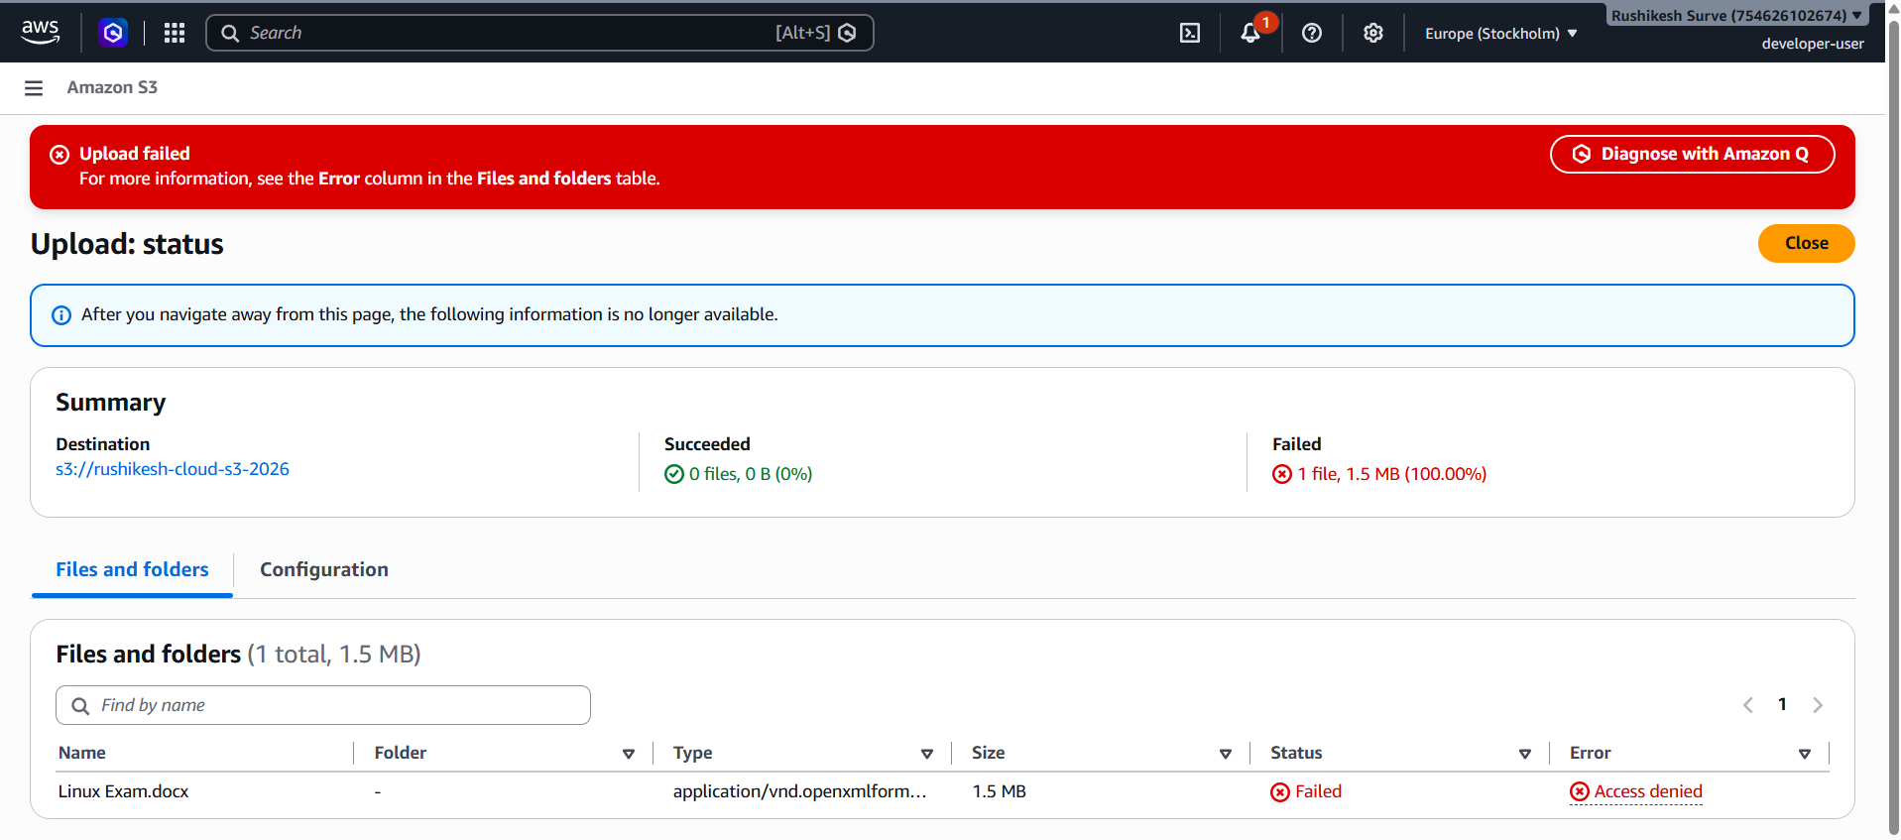

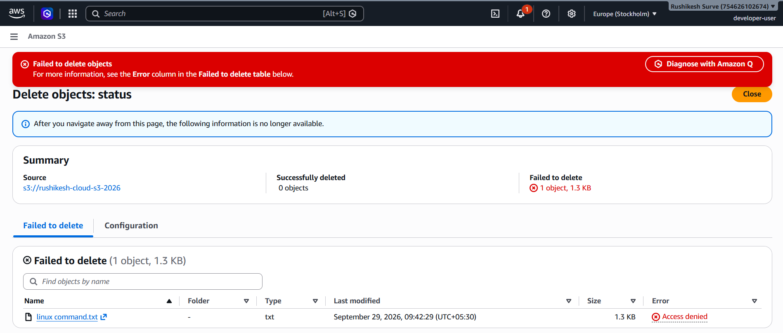

Section B

Create a uniquely named S3 bucket in the AWS Region specified by your instructor.

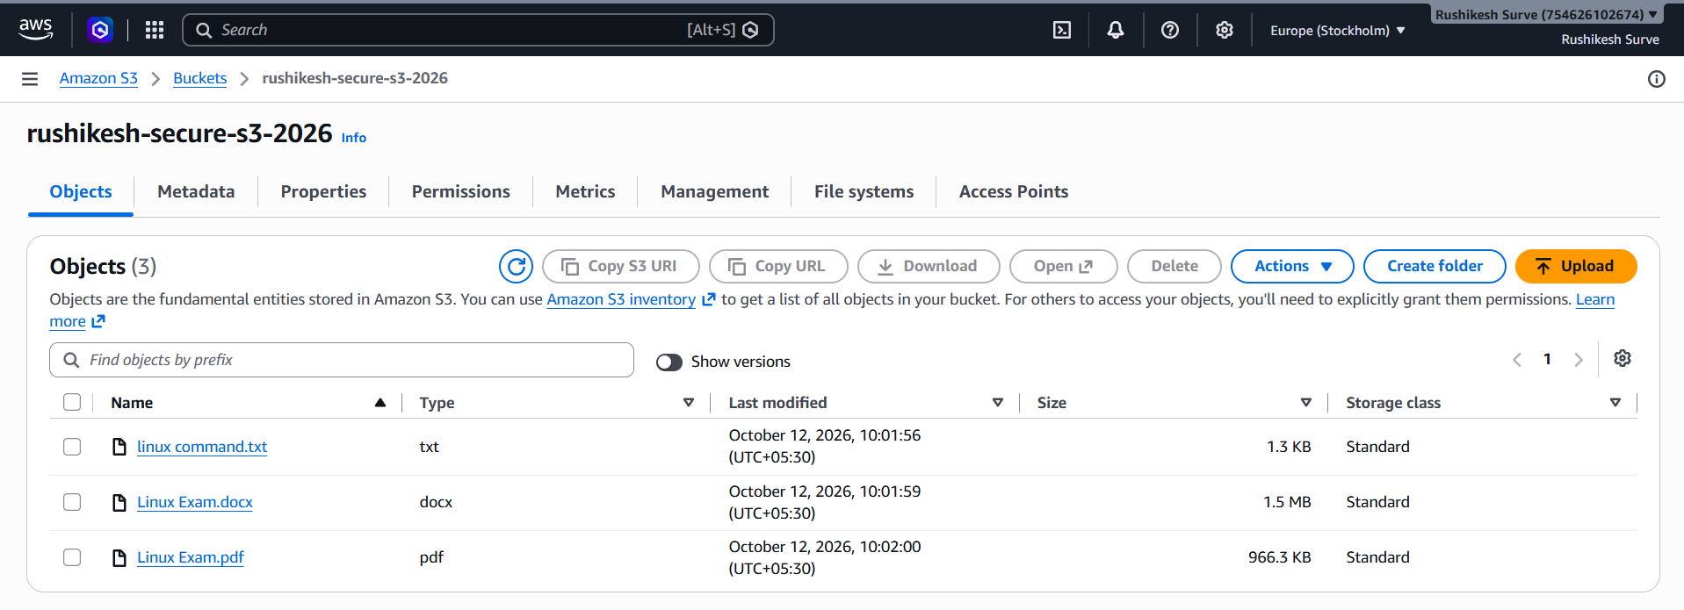

Keep Block Public Access enabled.
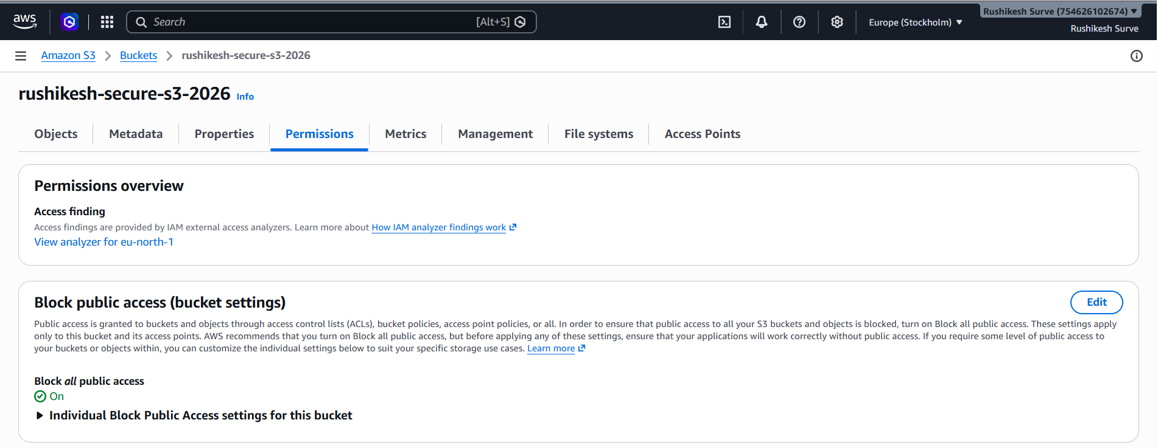
Enable default server-side encryption using the available AWS-managed encryption option.
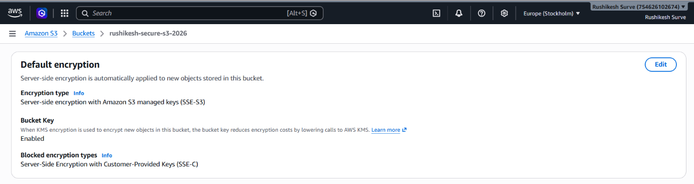

Upload three sample files to the bucket.

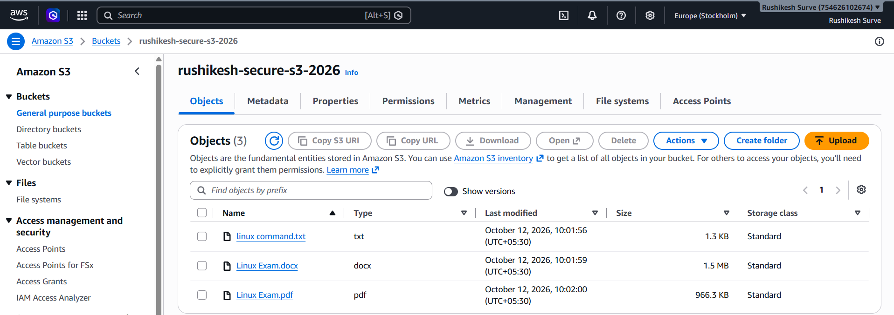

Create the prefixes documents/, images/, and backups/ in your bucket.
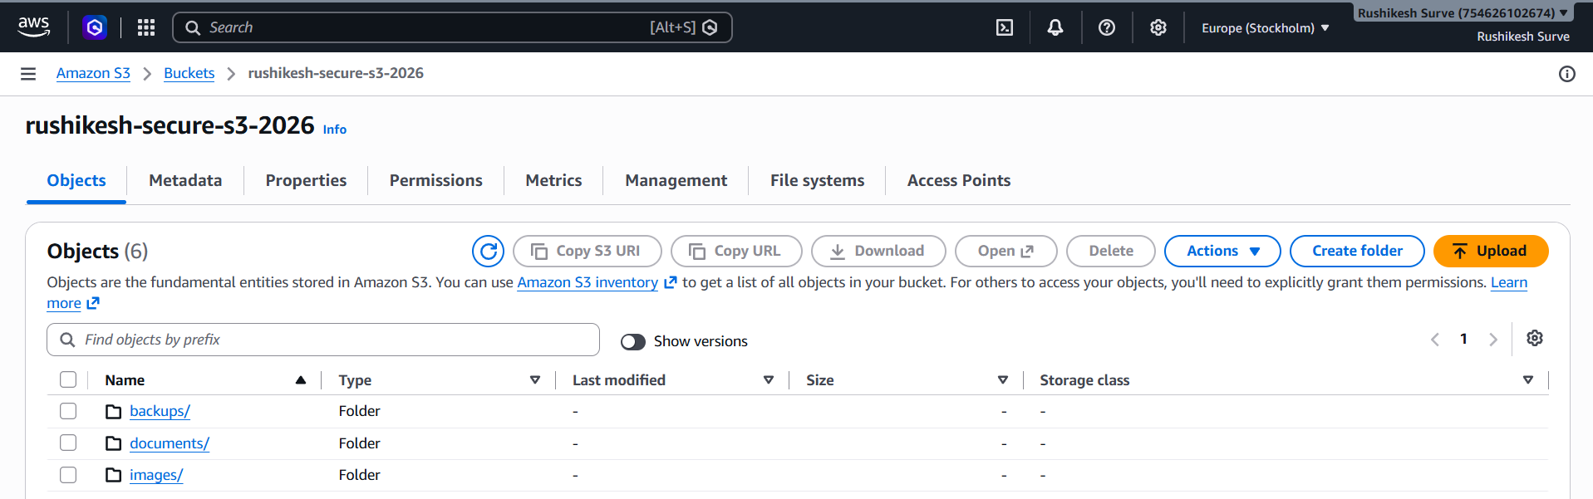

Enable bucket versioning.

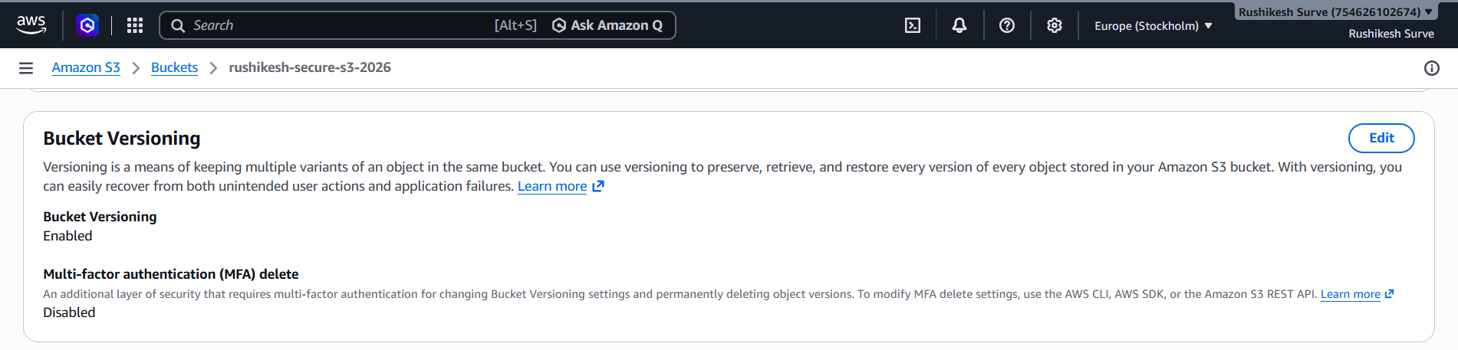

Upload report.txt, change its content, and upload it again using the same object key.
Show the versions and demonstrate how to restore the earlier content as the current version.

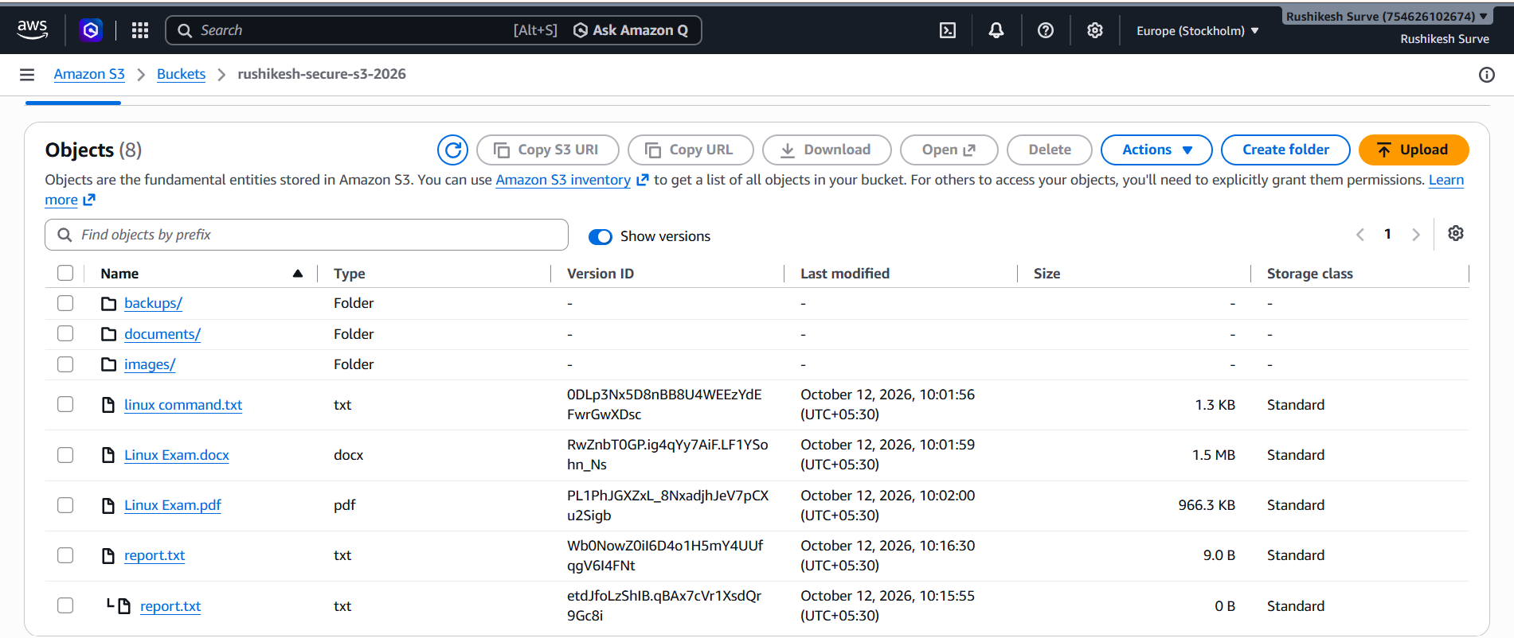

Configure the bucket so that the IAM principal developer-user can read objects from it.
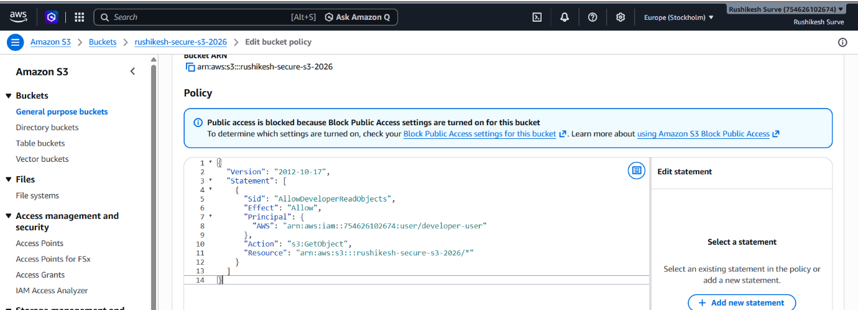
Use the correct bucket and object ARNs in the policy. 30. Keep anonymous/public access blocked. Do not add a public Allow statement.

31. Test access as the intended principal and explain how you confirmed that public access remains blocked.

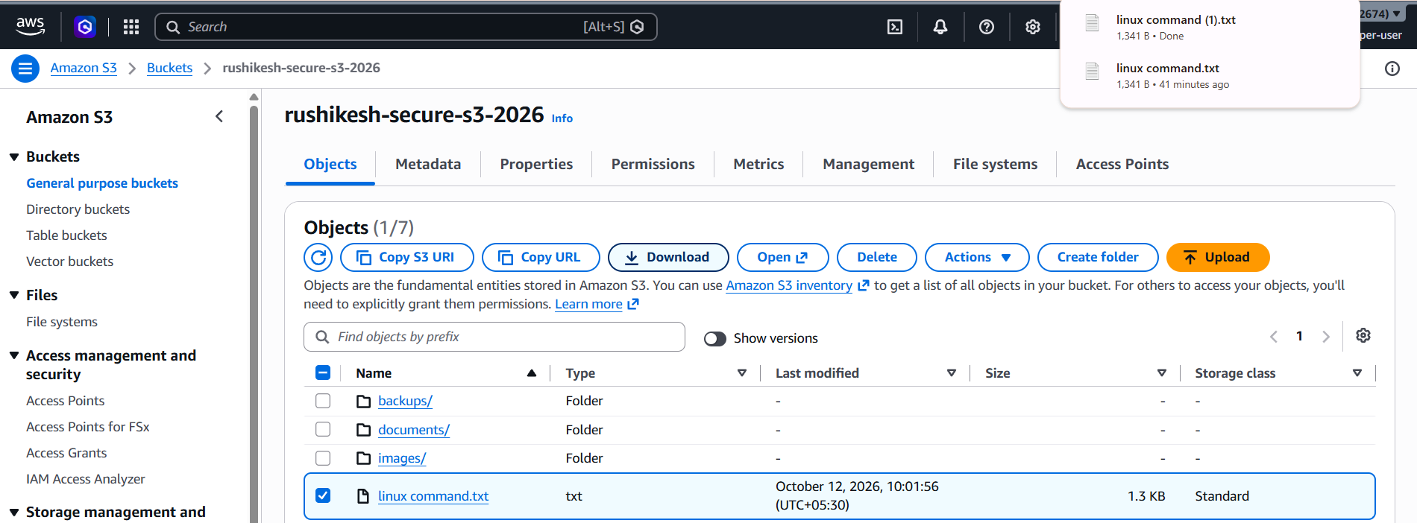

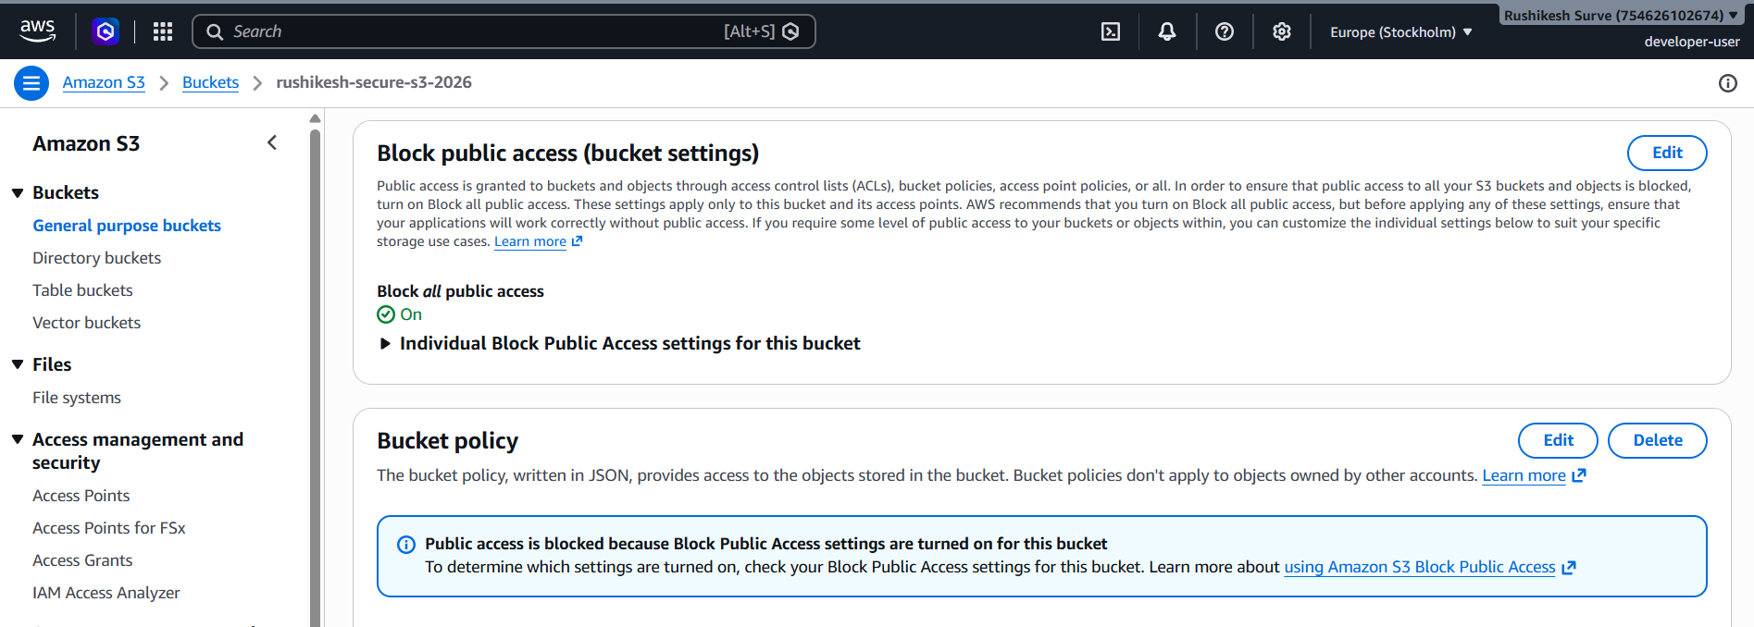

Create a lifecycle rule named BackupTransitionRule for objects under the backups/ prefix. 33. Configure eligible objects to transition to S3 Standard-IA after 30 days. 34. Ensure the rule is enabled and inspect the rule summary.

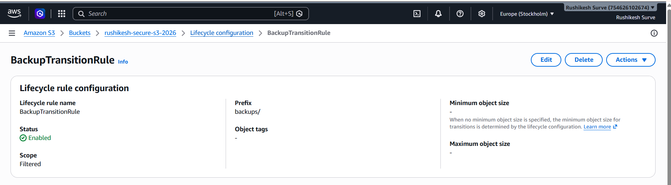

Create a separate destination bucket for access logs. 37. Configure the source bucket to deliver server access logs to the destination bucket. 38. Verify the logging configuration and destination permissions. 39. State why logs may not appear immediately after you enable logging.

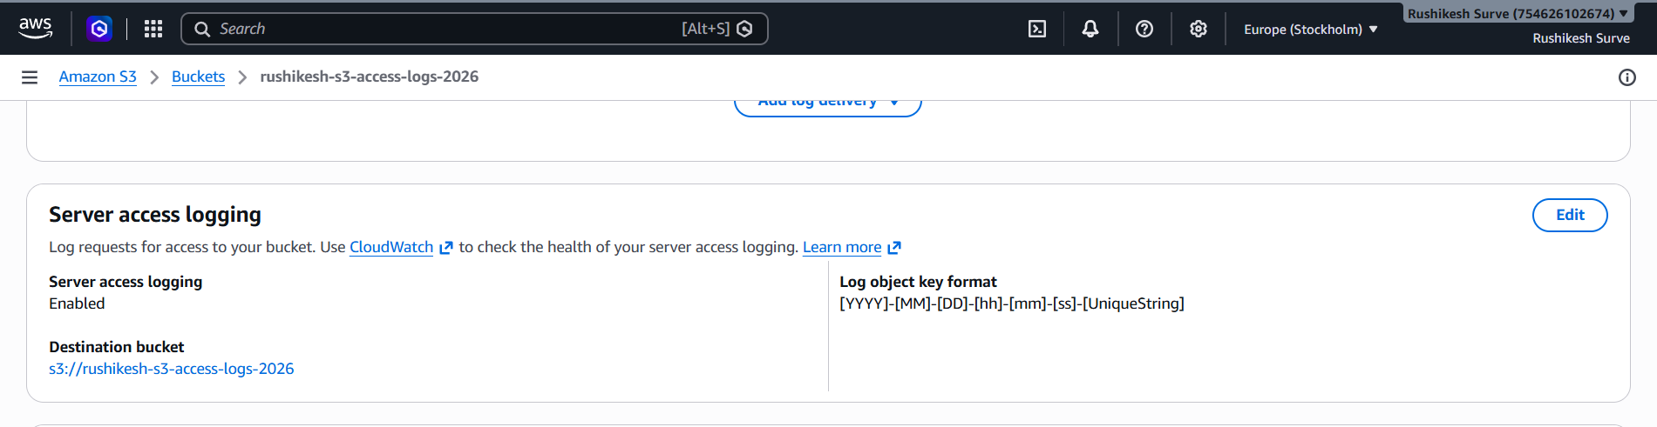

Open the properties of one uploaded object and identify the server-side encryption setting. 41. Explain the difference between IAM permissions and an S3 bucket policy.

